Official IOM T-Shirt Contest Rules
The International Outbreak Museum
NO PURCHASE NECESSARY TO ENTER OR WIN.

Promotion Period: The International Outbreak Museum (IOM) Outbreak Submission T-shirt contest begins March 1st, 2018 and ends March 31st, 2018. A winner will be chosen within 30 days of the promotion end date. We will contact the winner if additional online exhibit materials are needed.
Prize: The winner (or each member of the winning team) will receive a T-shirt in (choose one) small, medium, large, or extra large (subject to availability). In addition, your winning outbreak investigation will become an official IOM website online exhibit.
Special Requirements: Since the chosen winner’s exhibit will become an official online exhibit at www.outbreakmuseum.com, the aforementioned must be willing to work in a limited fashion with museum staff to finalize the online outbreak exhibit. This may include a request for additional information or materials (such as pictures, video, an epi curve, outbreak questionnaire, etc).
Eligibility: Anyone can submit an outbreak investigation. There are no restrictions for eligibility based upon geographic location or whether or not you participated in the submitted outbreak investigation. T-shirts will be shipped to the winners within 2-8 weeks (to the best of our ability).
How To Enter: You may enter this contest as an individual or a small team. To enter the contest, a historically significant outbreak investigation report must be submitted to International Outbreak Museum staff.
To submit your exhibit, please fill out the online exhibit submission form (Appendix A on page two of this document) and submit it along with any supporting materials (images, captions for images, publications, presentations, epi curve, etc) to the following email address: outbreak.museum@state.or.us
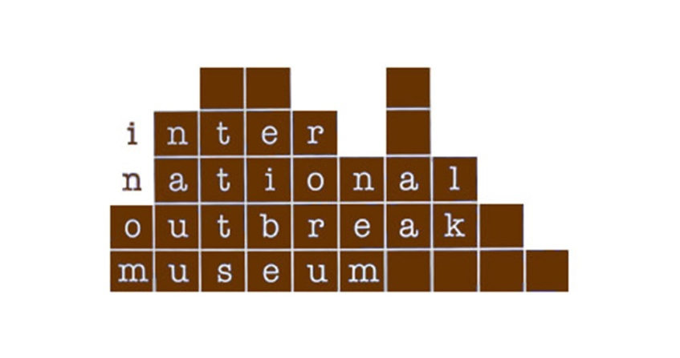

Appendix A - Outbreak Online Exhibit Submission Template
NOTE: For examples of current online outbreak exhibits, please visit www.outbreakmuseum.com and look through the exhibits section.
Please send this completed form to outbreak.museum@state.or.us :

SECTION 1
- Investigation jurisdiction (local Health Department, state Health Department, Federal, Other)
- Pathogen
- Vehicle/venue
- Case counts (confirmed/presumptive/suspect)
- Geographic distribution of cases (single county/state-wide/multi-state/International)
- First and last onset dates
- Pictures! (please include captions for each photo submitted as part of exhibit)
- Number of positive non-human specimens (water, environment, food, etc.)
OPTIONAL BONUS MATERIAL
- Publication citation (optional)
- Presentations (optional)
- Investigation tools (e.g., questionnaire) (optional)

SECTION 2
Please limit the 3 sections below to a total of ~1000 words
1) Abstract: Background, Methods, Results, Conclusions

2) Highlights: unique features or reasons why the outbreak is important

3) Lessons learned

